 | SR UNIVERSITY  Campus Warangal
 | Program: II - B. Tech (CS& AI) Batch:
 | Name: D.SAI VISHWANATH Reg.No:2503A52443
 | Department: Computer Science and AI Semester: I
 | AI Assisted Coding-Assignment Date: 22-09-2026

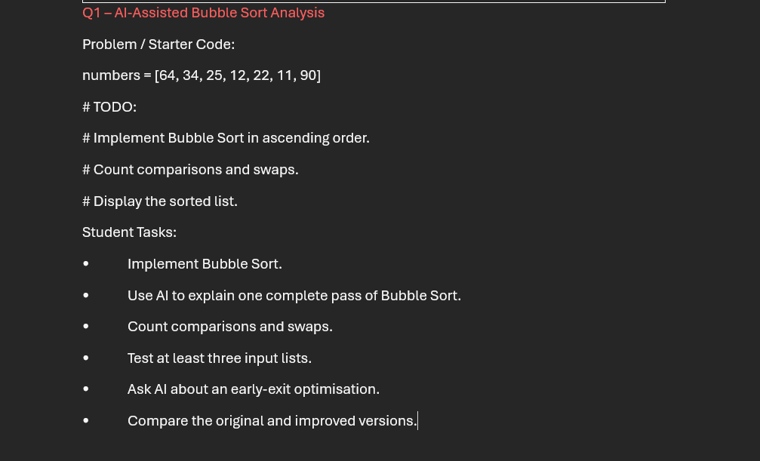

PROMPT:
Suggested AI Prompt:
“Explain Bubble Sort step by step for the given list. Identify opportunities to reduce unnecessary comparisons. Do not write the complete program yet.”
CODE: 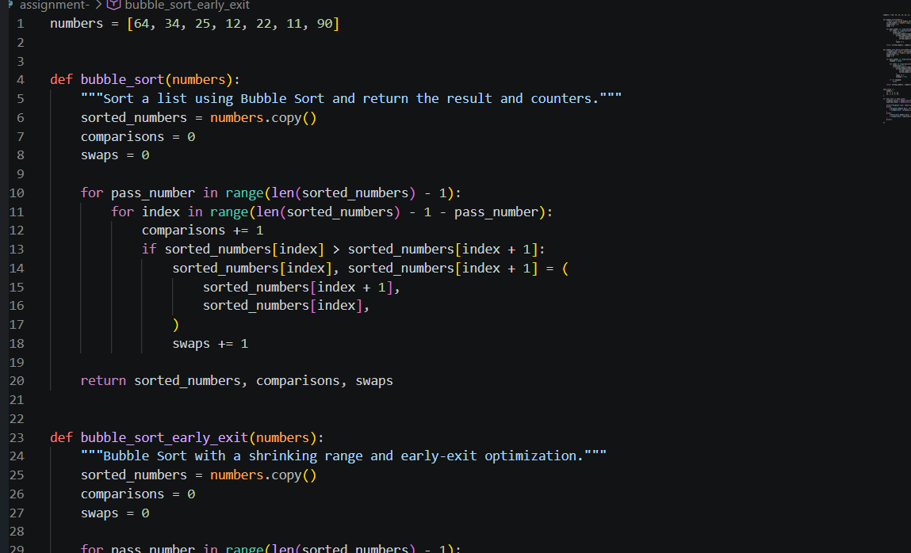
OUTPUT: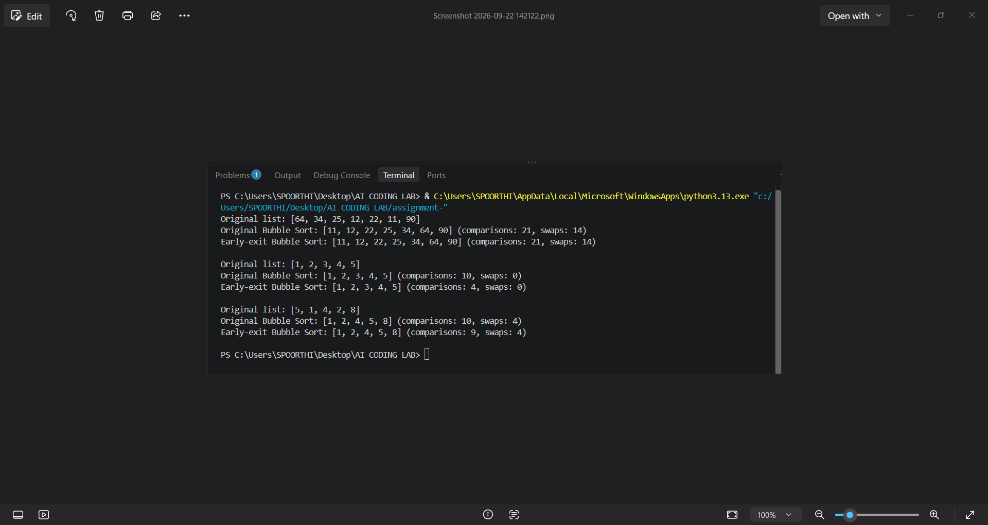

OBSERVATION:

* Bubble Sort compares adjacent elements and swaps them.
* The list is sorted in ascending order.
* Each pass moves the largest element to the end.
* Comparisons and swaps depend on the input list.
* Early-exit stops sorting when no swaps occur.
* Early-exit makes Bubble Sort faster for sorted or nearly sorted lists.
QUESTION-2
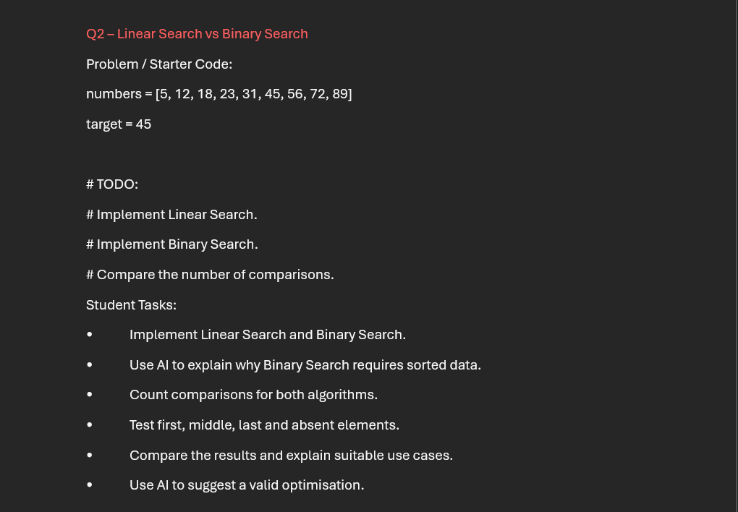
PROMPT:
Implement Linear Search and Binary Search for the given list, count and compare their comparisons for first, middle, last, and absent elements, explain why Binary Search requires sorted data, compare suitable use cases, and suggest one valid optimization.
CODE: 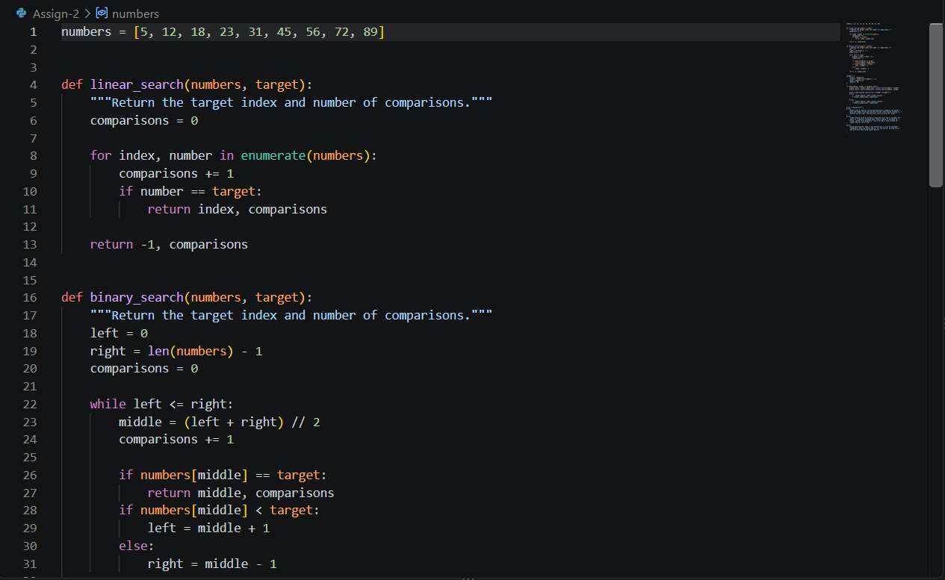
OUTPUT: 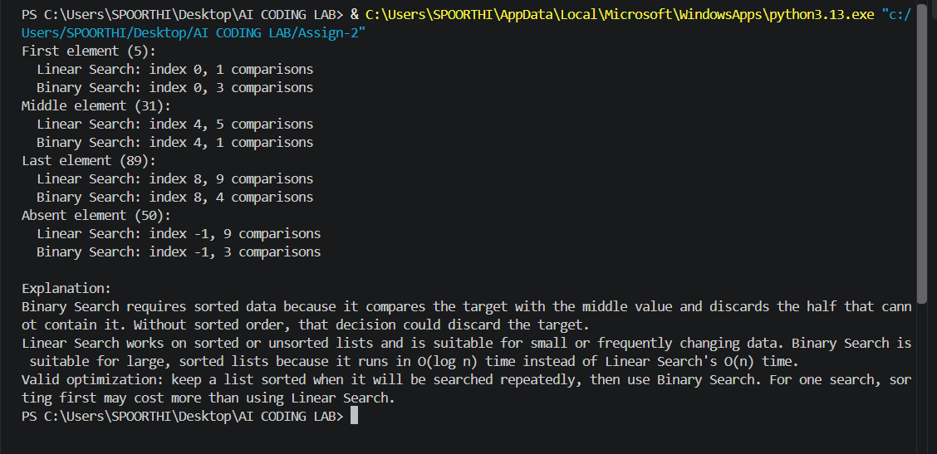
OBSERVATION:

* Linear Search checks elements one by one and works on sorted or unsorted data.
* Binary Search is faster but requires the list to be sorted.
* Binary Search uses fewer comparisons for large datasets.
* For small or unsorted lists, Linear Search is simple and suitable.
QUESTION-3
Q3 – Compare Sorting Algorithms
Problem / Starter Code:
data = [45, 12, 78, 34, 23, 89, 5, 67, 10, 56]
# TODO:
# Sort using Bubble Sort, Selection Sort and Insertion Sort.
# Compare their performance.
Student Tasks:
• Implement all three sorting algorithms.
• Use the same input for each algorithm.
• Count comparisons and swaps/shifts.
• Use AI to explain strengths and weaknesses.
• Ask AI which algorithm suits nearly sorted data.
• Compare experimental results with theoretical complexity.
PROMPT:
Implement Bubble Sort, Selection Sort, and Insertion Sort for the given data, count comparisons and swaps/shifts, compare their strengths, weaknesses, time complexities, and identify which algorithm is best for nearly sorted data.
CODE:
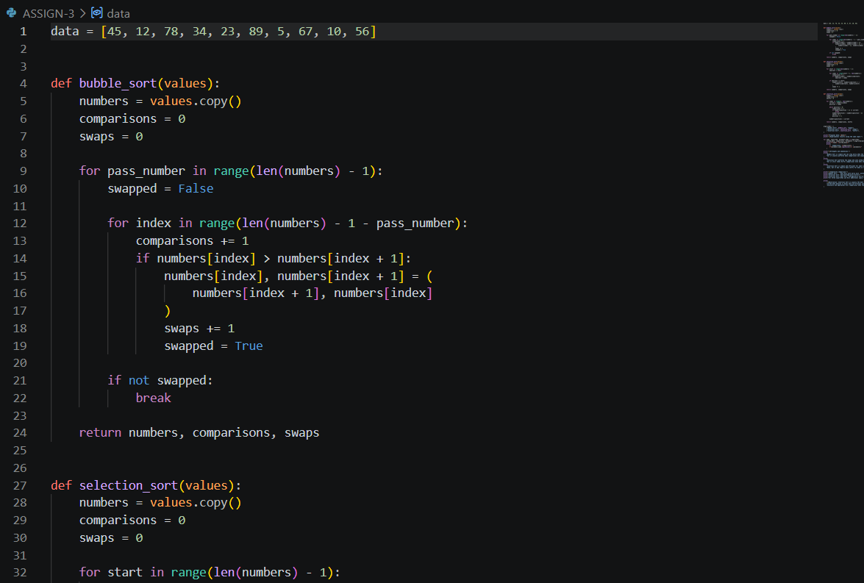
OUTPUT:
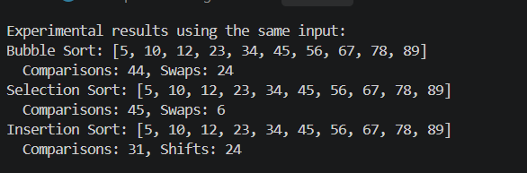
OBSERVATION:
- All three algorithms correctly sort the same input data in ascending order.
- Bubble Sort and Selection Sort generally require more comparisons.
- Insertion Sort performs well when the data is nearly sorted.
- All three have O(n²) average/worst-case time complexity.
- The practical performance depends on the input order and number of swaps/shifts.

QUESTION-4
Optimising a Student Search and Sort Program
Problem / Starter Code:
students = [
("Arun", 82),
("Bala", 65),
("Chitra", 91),
("Divya", 74),
("Esha", 88)
]

# TODO:
# Find the highest mark.
# Sort students by mark.
# Search for a student by name.
# Improve the solution using AI.
Student Tasks:
• Write functions for highest mark, sorting and name search.
• Create a straightforward solution first.
• Use AI to identify unnecessary operations.
• Ask AI for a more efficient approach.
• Implement only suggestions you understand.
• Compare original and improved time complexity.
PROMPT:
Implement functions to find the highest mark, sort students by mark, and search by name, then analyze the straightforward solution, identify unnecessary operations, suggest an efficient approach using AI, and compare the original and improved time complexities.
CODE:
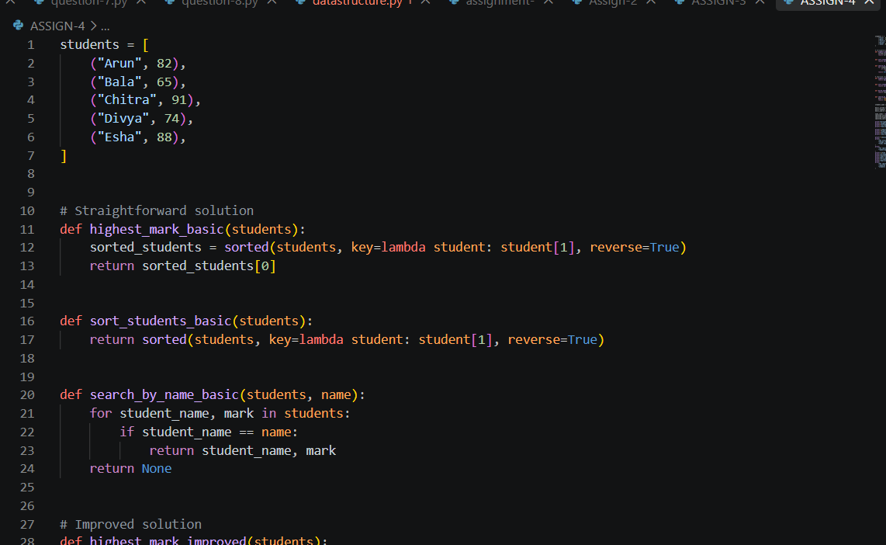
OUTPUT:
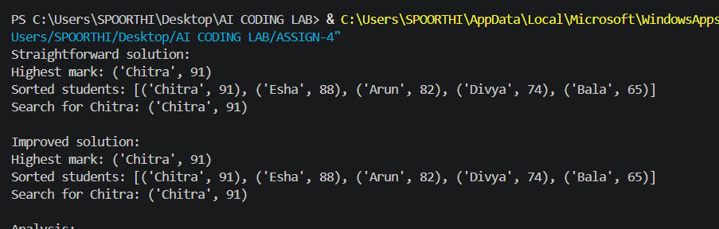
OBSERVATION:

- The program successfully finds the highest mark, sorts students, and searches by name.
- The straightforward approach may repeat some operations unnecessarily.
- Using efficient searching and sorting methods can reduce execution time.
- The improved solution has better performance for larger student datasets.
QUESTION-5
Q5 – Optimisation Challenge: Best Combination
Problem / Starter Code:
items = [
("Laptop", 60000),
("Phone", 30000),
("Tablet", 20000),
("Watch", 10000),
("Headphones", 5000)
]
budget = 50000
# TODO:
# Find a combination of items whose total price
# is as high as possible without exceeding the budget.
Student Tasks:
• Design a solution to maximise total value without exceeding the budget.
• Start with a simple approach and explain it.
• Use AI to compare Brute Force, Greedy and Dynamic Programming.
• Determine which approach guarantees an optimal solution for this formulation.
• Implement the selected solution.
• Test at least three budgets.
• Explain time
PROMPT:
Solve the item combination problem using Brute Force, Greedy, and Dynamic Programming, compare their approaches and time complexities, identify which guarantees an optimal solution, implement the best approach, and test it with at least three different budgets.
CODE:
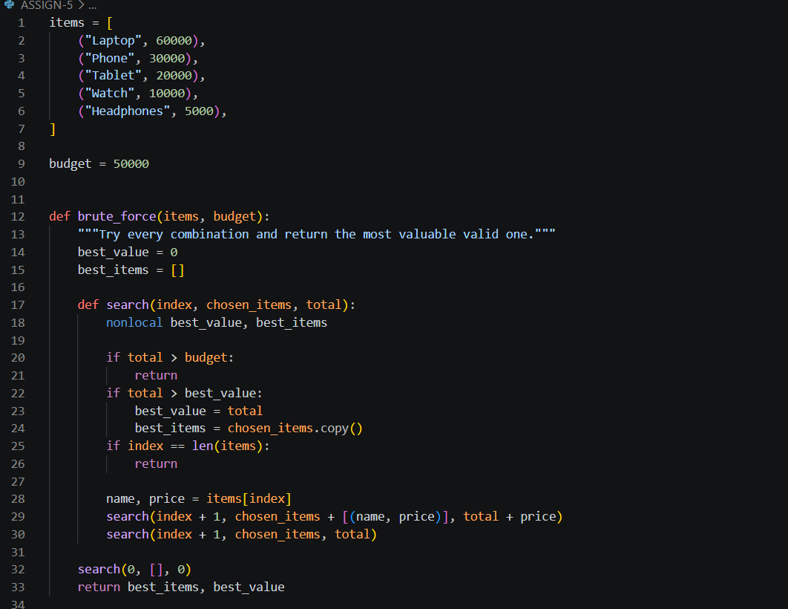
CODE:
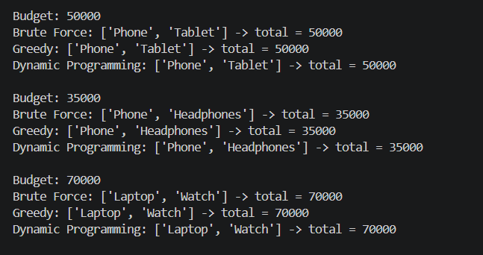
OBSERVATION:

* The program finds the combination of items with the maximum total price without exceeding the budget.
* Brute Force checks all possible combinations and guarantees an optimal solution.
* Greedy is faster but does not always guarantee the optimal combination.
* Dynamic Programming can efficiently find an optimal solution for larger inputs.
* The best approach depends on the number of items and problem constraints.
SSS

